Alg 4 Summer Name: ____________________________

______________ _____________

WS Assessment

Target 10:

normal distribution

**I can:**

* Understand the normal distribution curve.
* Use the mean and standard deviation of a data set to fit it to a normal distribution and to estimate population percentages.

**Unit 9: Statistic**

[**HSS.ID.A.4**](http://www.corestandards.org/Math/Content/HSS/ID/A/4/) Use the mean and standard deviation of a data set to fit it to a normal distribution and to estimate population percentages. Recognize that there are data sets for which such a procedure is not appropriate. Use calculators, spreadsheets, and tables to estimate areas under the normal curve.

Normal Distribution Curve

1. The following data is a set of scores from all of the applicants for a police academy. Enter the data below into your desmos

d = [ 84,73,55,93,85,78,66,97,89,75,94,80,77,78,45,68,90,62,85,100,98,71,82,87,94,75, 87,82,80,64 ]

To check if your data was correctly entering, we do check sum,

desmos: *total(d)* If you get 2394 show me stamp _________________

Fill in all info below

|  |  |  |  |  |  |  |  |
| --- | --- | --- | --- | --- | --- | --- | --- |
| Mean ***µ*** | Sample Standard deviation | Population Standard deviation | Data at minimum | First Quartile | Median (2nd Quartile) | Third Quartile | Maximum |
| mean(d) | stdev(d) | stdevp(d) | min(d) | quartile(d,1) | quartile(d,2) | quartile(d,3) | max(d) |
|  |  |  |  |  |  |  |  |

Create a histogram with bin width = 10 Create box plot

desmos: histogram(d, 10) alignment= left desmos: boxplot(d)

change y-step = 1

Sketch and stamp Sketch and stamp

Normal distribution curve

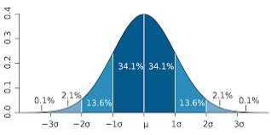 ***µ = mean*** and ***σ = standard deviation***

The interval µ ± 1σ covers the middle

∼ 68% of the distribution.

The interval µ ± 2σ covers the middle

∼ 95% of the distribution.

The interval µ ± 3σ covers the middle

∼ 100% of the distribution

Create a normal curve. What is the mean ***µ*** ____ What is standard deviation ***σ_____***

desmos : normaldist(***µ, σ***)

Set window at

Xmin = mean - 3 stdev Xmax = mean + 3 stdev Xscl = stdev  
Ymin = 0 Ymax= 1 / (2 stdev) Yscl = 0

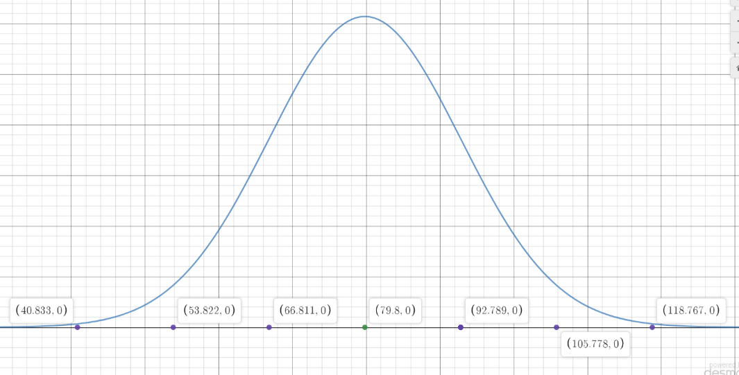

Indicate the mean and ± 3 standard deviation . Show me for stamp

The academy will automatically accept anyone who scores at least one standard deviation above the mean. Which scores will gain automatic acceptance? ____________________

How many candidates are accepted? _____________________

*A* ***z*-score** is used to standardize a **raw score** (the actual original score) $Z=\frac{X-μ}{σ}$

This allows statisticians to compare scores from different individuals who may have taken a different test. For a *z*-score of 0 🡪 🡪 indicate **mean value.** A *z*-score of –1 indicate **one standard deviation below the mean**

Joren scored an 82 on his police academy test.

Find his z-score **______________** Is he get accepted?

Person can retake the test if he/she has a z-score > -0.5, Can Joren retake the test? ____________

Will Ryan whose score is 73 retake the test? ______. What is Ryan z-score? ________

2. One of the most common places where the normal curve is used is on the SAT tests given by the College Board. They scale the raw scores for the verbal and math sections so that the scaled mean will be 500 with a standard deviation of 100. Indicate the score on the normal curve below

Mary scored 550 on her math SAT. What is her z-score? ______________

Create SAT’s normal curve and show Mary’s score for stamp

Sketch it here Estimate the percent of people

above her __________%

and below her ___________%

In 1994 the College Board revised the scale, and the actual mean on the math SAT for 1995 was 504 with a standard deviation of 110.

Re-sketch the curve. What would Mary score will be if

her Z-score is maintained the same?

(Find X =?)

A set of data has a mean of 92 and a standard deviation of 8. Show your computation

a. If a student has a raw score of 110, b. How many standard deviations above

what is his *z*-score? the mean (z-score) is a raw score of 104?

c. What *z*-score corresponds to a d. What raw score corresponds

raw score of 88? to a *z*-score of –1.75?

3. Consider two complete sets of test data. Find the mean and standard deviation of each set.

Test A: 57 76 79 95 67 89 73 68 84 Test B: 29 93 89 95 72 75 90 87 52

mean ***µ*** = sd ***σ*** = mean ***µ*** = sd ***σ*** =

z-score = z-score =

Who would have more reason to rejoice — the person who earned a 95 on Test A or on Test B? Explain using z-score. Show both normal curve on one screen for stamp and sketch it here.

Normal Density Function

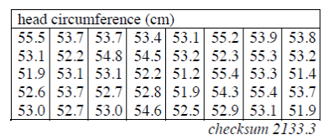4. The company collected the data below for women’s head circumference by measuring 40 randomly-selected volunteers at charity events.

Enter the data in desmos

d = [ … ] and find:

The mean head circumference

***µ*** _______ and standard deviation ***σ_____*** for these women?

On your calculator, make a histogram of the distribution of women’s head circumferences. Use an interval from 50cm to 57cm with a bin width of 1.(*This called a count histogram*)

Show me for stamp _____________

Hat size is determined by the whole-number portion of a woman’s head circumference. For example, a woman with a head measuring 55.8cm would need a size 55 hat. According to your histogram, how many women need a size 52 hat? ____________________

What *percent* of women have a hat size less than 54? ____________________

Now change your count histogram to relative histogram. Show me for stamp

|  |  |  |
| --- | --- | --- |
|  |  |  |

|  |  |  |
| --- | --- | --- |
|  |  |  |

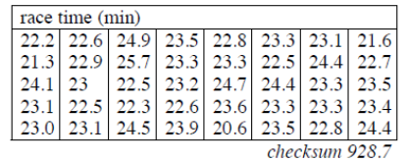5. The 40 women in the sample recorded their race times in various charity 5K races in the table below.

a. Find the mean and standard deviation of the race times to four decimal places.

b. Show me both count histogram and relative histogram for stamp. Sketch them here.

Probability Density function

Much of the real data that is encountered in science, business, and industry can be modeled with a bell-shaped curve, called a **normal probability density function**. The mathematical formula is complex, (you have it in AP Stats) but your calculator can draw it very easily once you determine the mean and standard deviation of the data.

Back to prob 5 on previous page. Let’s model the women’s 5K times with a normal probability density function.

mean ***µ*** = stdev ***σ*** =

Sketch the normal distribution curve.

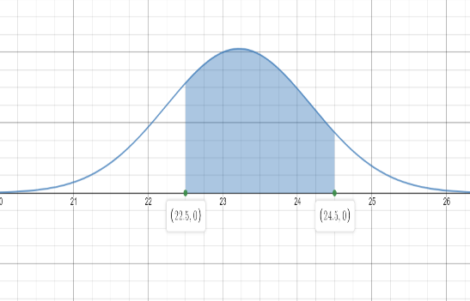

What percent of women have running times between 22.5 and 24.5 minutes?

Show me this for stamp

Redo it using the function desmos: *normaldist(mean, stdev).cdf(22.5,24.5)*

What percent of women have running times between 20 and 25 minutes?

Show me for stamp both ways: graph and function

What percentage of all women in the population run faster than 24 minutes according

to your model? Write your desmos function here

What percentage of all women in the population run lower than 24 minutes according

to your model? Write your desmos function here

Make a prediction with your model for the percentage of women that fall below the mean running time. Do you say 50%. So me the math for stamp _____________________

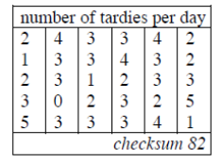**Target 10 Assessment**

**I can**… apply normal distribution function

1. Some students at North City High are abusing the privilege of being allowed to leave campus for lunch. The number of tardies to Mr. Greene’s period after lunch is too high. In the last 30 school days, she recorded the number of tardies shown in the histogram at right.

* What is the percentage of 3 student -tardy per day in this month?
* How many days were 3 student-tardy per day in this month?
* How many days were 3 or more students tardy?

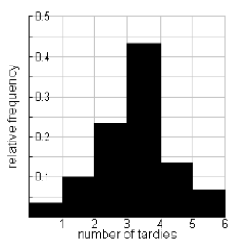Recreate this frequency histogram for stamp

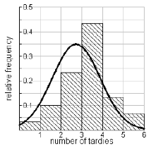We are going to fit a normal model to the number of tardies to the histogram above. The data Mrs. Greene gathered for 30 days is shown in the table at right.

mean ***µ*** = sd ***σ*** =

Graph the normal distribution curve together the frequency histogram. When you have the picture like below, show me for stamp.

X is a normally distributed variable with mean μ = 30 and standard deviation σ = 4.

Find the z-score of

x = 34 x = 21 x = 30 x = 36

z = ? z = ? z = ? z = ?

Using the given normal distribution function and graph, find the distribution function of (sketch)

P(x < 34) P(x > 21) P(30 < x < 35)

A radar unit is used to measure speeds of cars on a motorway. The speeds are normally distributed with a mean of 90 km/hr and a standard deviation of 10 km/hr. What is the probability that a car picked at random is traveling at more than 100 km/hr P(x > 100)?

The length of human pregnancies from conception to birth approximates a normal distribution with a mean of 266 days and a standard deviation of 16 days. What proportion of all pregnancies will last between 240 and 270 days (roughly between 8 and 9 months)? Show graph for stamp